Whole School Engagement

Stephen Pinel

Abstract: Students come to our schools and classrooms from a range of contexts, home experiences and different school experiences. These experiences can have a profound impact on the engagement they display when they enter our classrooms. An understanding of the different learning behaviours of our students, and how engagement impacts on those behaviours, can assist in helping schools and teachers develop whole school programs and teaching techniques that will both engage as many students as possible to their best possible extent, and also work to improve the engagement of each students. Using Schlechty’s model of engagement, a sample of Learning Theories, well being and behaviour management processes, and Teaching Techniques are linked together to create a framework for improving Whole School Engagement.

Table of Contents
1. Introduction 3
1.1. Critique of Authenticity & Authentic Learning in the Literature 3
1.2. Learning Theories and Instructional Theories 4
1.3. Behaviourism 5
1.4. Constructivism 5
1.5. Cosmopolitanism 6
1.6. Enactivism 6
1.7. Summary of Learning Theories and links to student engagement 7
2. Critical Reflection on Practices 9
2.1. Context 9
2.2. Reflection on current practices 9
3. Conclusion 13
Bibliography 14
Appendix A 16

Introduction
The art and purpose of authentic teaching is in being able to engage students authentically. Students that are authentically engaged are students that take responsibility for their own learning, retain and can apply knowledge in other contexts, and care more about their own educational and cognitive development than about the formal outcomes, or grades, that are achieved (Andrews, 2014).
In order to engage students, we must be able to understand our students, and be able to select appropriate instructional techniques for each particular context. A solid understanding of the links between Learning Theory (how students learn) and Instructional Theory (how to help students learn) (Schuh & Barab, 2008, p. 76), which informs instructional technique is critical to this process. In this paper, Authenticity and Authentic Teaching will be defined and discussed, along with a number of different Learning Theories that can be selected from, in order that student engagement can be improved. In these sections, some of the current literature will be critically reviewed, which will inform some personal reflection of some of my recent teaching experience.

Critique of Authenticity & Authentic Learning in the Literature
Students, particularly at high school, are very switched on to identifying work that they feel may add value to their life, and work that they see simply as “busy work”. Lombardi (2007, p. 2) defines Authentic Learning as learning that has characteristics such as being real-world and complex, are real life case studies, and require collaborative solutions. This is similar to Rule’s definition of Authentic Learning as learning that “mimics real world situations” (2006, p. 2). However, in my experience, students and teachers do not always agree on whether an activity could be described as Authentic. Peterson discusses Authenticity in the context of music performance, making the point that despite there being numerous paths towards authenticity (eg cultural identity, status), each claim of authenticity is ultimately tested and validated by the audience, not the performer (Peterson, 2005). It follows, then, that as much as we as teachers may design lessons and units to be authentic according to the earlier definitions, their actual authenticity will not be validated until we bring them to the students. That is, a topic or problem being authentic is not, of itself, sufficient to allow authentic learning to occur, the topic or problem must also be seen to be authentic by our students.
One of the characteristics of an authentically engaged student, according to Schlechty (2011), is that knowledge is retained after the fact of assessment for grades. There are students in our classrooms who may outwardly appear to be engaged in school work but work hard primarily to receive good grades, rather than for the learning itself, and soon forget the knowledge they have learnt. They are described by Schlechty as being Strategically Compliant (see Table 1 on p8), rather than Authentically Engaged This appears to be an important distinction between these students, and students who see their work as authentic, in that is has value beyond the classroom. This characteristic of authentic learning has been identified by others, such as Machiavelli, who in the introduction of The Prince, reflects on his own learning, and quotes Dante, saying
“Knowledge doth come of learning well retained, Unfruitful else”
(Machiavelli, 1513)
In the following sections, I will be referring to Schlechty’s model of engagement, and use it identify which of the following Learning Theories are appropriate to use in different contexts, and with students at different levels of engagement.

Learning Theories and Instructional Theories
Theories are systems of ideas intended to explain a collection of observed facts (Peters, 2014). Learning Theories are, therefore, systems of ideas that are intended to explain they way in which we observe students learn. Similarly, Instructional Theories are used to explain how the various observed teaching techniques work to help student learning (Schuh & Barab, 2008, p. 76). In this essay, the focus will be on various Learning Theories, although some instructional techniques (elements of Instructional Theories) will be identified as having characteristics that work well with certain Learning Theories.

Behaviourism
Behaviourism as a Learning Theory can be described as direct transmission of knowledge from teacher to student. It follows from this that Behaviourism does not require interaction between learners, or even between learners and actors outside of the classroom. Ontologically, Behaviourism is Objective in nature as the facts of the world are seen to be independent of human understanding or interaction with the world. Programmed Instruction, Explicit Instruction and Direct Instruction are all teaching techniques that are based on Behaviourism as a Learning Theory (Schuh & Barab, 2008, p. 76). Each of these techniques make it very clear to students what is expected for them to succeed, but give students no ownership of learning, and so tend to result in low commitment, other than what is immediately required for each lesson. Proponents of these styles of Instruction often value teacher accountability, and describe these techniques as evidence-based in terms of producing improved results. However, accountability as a strategy for improvement is a relatively poor way to look for improvements in outcomes. (Fullan, 2014, p. 27) If teachers are primarily accountable for the data and results they produce, then that will become the focus (Kreber, 2013, p. 859). Behaviourism, as a learning theory, works well for students who are working at the level of Ritual Compliance, in that they have low commitment and attention, but will do what is asked by the teacher in order to avoid negative consequences.

Constructivism
Constructivism as a Learning Theory assumes a greater role for relationships between learners and the world than in Behaviourism. The teacher is no longer the only source of knowledge or facts, and students construct knowledge gained both from the teacher, and from their own experiences and sources outside of the classroom. As in Behaviourism, the world exists independently of us, however there is an acceptance in Constructivism that it cannot be well defined (Schuh & Barab, 2008, p. 71), and therefore has at its base Realism as its Ontology. Constructivism describes the reorganisation of information (learning) as an individual activity (Ausubel, 1961), and so Programmed Learning and similar forms of instructional techniques used in Behaviourism are inappropriate. However, students may still be guided in their learning by the teacher, so the provision of clear lesson intentions and success criteria can be useful instructional techniques to allow students to judge their own success as learners, although the criteria for success are still set by the teacher rather than the student themselves. Students that show a high level of attention, but without ownership of their own learning, learn well under Constructivist learning theories, and can best be described as Strategically Compliant under the Schlechty model for engagement.

Cosmopolitanism
In some ways similar to Constructivism, Cosmopolitanism as a Learning Theory also posits that students construct knowledge by reorganising information from a variety of sources, including the classroom teacher, and other sources such as their own experiences. Cosmopolitanism differs from Constructivism in that Cosmopolitanism describes learning as a collaborative activity, and occurs as students collaboratively engage with the world. The ontology of Cosmopolitanism is Relativism, given the clear importance given to the relationships between ideas, cultures and people (Schuh & Barab, 2008, p. 71). Cosmopolitanism implies an openness to ideas and cultures that are different to our own, as a result of interaction with other people, cultures and ideas (Saito, 2010, p. 334). This requires, from students, a high level of commitment in order to reorganise existing schema to accommodate different ways of thinking, however the end result can be more enlightened and mature students, as their high level of work commitment causes a similar high level of commitment to alternate cultures and ideas (Saito, 2010, p. 342). Instructional Techniques appropriate for Behaviourism are certainly not appropriate, and even Learning Intentions and Success Criteria need to be personalised, or negotiated between teachers and students. Interaction between students and other cultures can be assisted through eLearning and digital pedagogies. Under the Schlechty model, students working at this level are Authentically Engaged, as they are frequently directing their own learning, for their own purposes.

Enactivism
The ontology, and the instructional techniques, for Enactivism are very closely related to those for Cosmopolitanism. The key difference between Cosmopolitanism and Enactivism is that while Cosmopolitanism focuses on collaborative learning through observations and interactions with the world at large, Enactivism also identifies actions that result from that learning as a part of the learning process. In other words, the learning process can itself result in action that changes the world we are studying (Sumara & Davis, 1997, p. 415). Enactivism will obviously only be relevant for students that are highly committed to their studies in a personal way, and own their education as a way to improve the world. These students are also identified as being Authentically Engaged in the Schlechty model, as students highly committed to their own learning. Project Based Learning is an effective way for students to both learn about their world and learn how to make changes to the world at the same time. While designed for first year engineering students, the Engineers Without Borders Challenge is an example of the sort of instructional technique that embodies Enactivist thinking (Engineers Without Borders, 2014).

Summary of Learning Theories and links to student engagement
Measuring student engagement accurately can be a difficult task. Schlechty has developed a model that identifies five different levels of student engagement, from Rebellion to Authentic Engagement (Schlechty, 2011). Student engagement is measured on two domains, Attention and Commitment, where only students who show high attention and high commitment are identified as being authentically engaged. The characteristics of the various Learning Theories described above match the needs of students at different levels of engagement as well as appropriate instructional techniques as shown on the next page in Table 1.

Schlechty Levels of Engagement | Rebellion | Retreatism | Ritual Compliance | Strategic Compliance | Authentic Engagement
Characteristics of the Learner | Diverted Attention  No Commitment | No Attention  No Commitment | Low Attention  Low Commitment | High Attention  Low Commitment | High Attention  High Commitment
Appropriate Learning Theories | Nil | Nil | Behaviourism | Constructivism | Cosmopolitanism  & Enactivism
Characteristics of Learning Theories | Behaviour Management and Wellbeing strategies used to move students towards Retreatism | High Classroom Expectations and Wellbeing strategies used to move students towards Ritual Compliance | Direct transmission of knowledge from the teacher | Learning from the world, (ie from sources beyond the teacher) | Learning from the world, collaboratively with peers (Cosmopolitism), and through interaction with the world (Enactivism)
Examples of Instructional Techniques |  |  | Programmed Instruction,  Differentiation | Discovery Learning,  Learning Intentions | PBL,  Personalisation
Table 1: Student Engagement and some appropriate Learning Theories (&Techniques) (Schlechty, 2011) (Schuh & Barab, 2008)

Critical Reflection on Practices

Context
At my previous school, I was the Physics teacher and Head of Science. It was a medium sized rural state high school in Queensland, with a student population of about 900. The school, at the time, was the only high school in the district, and so catered for all students, across a broad range of socio-economic groups and academic ability. The school had an indigenous population of about 5%, with a very small number of students from a Non-English Speaking Background.
Under the previous Principal, the school had introduced a 1 to 1 laptop program, with about a 95% uptake amongst students. Staff professional development was focused on developing innovative teaching practices, and integrating eLearning into all teaching areas. No specific pedagogy framework was implemented school wide, although there were a range of instructional techniques and planning frameworks implemented, including eLearning strategies, 21 Century Learning Design, and Personalisation. (Microsoft Educator Network, 2015).
During this period of time, the school’s NAPLAN results were amongst the highest in the Region, although the Region itself was the worst performing Region in the state. Data from the annual School Opinion Survey showed that the staff were very comfortable in the use of technology and eLearning pedagogies, amongst the top in the state. I started collecting data on student engagement at the end of this period, using the Partners in Learning School Research report, provided by the Microsoft Educator Network (Microsoft Educator Network, 2015). The data can be seen in Appendix A.

Reflection on current practices
The current Principal has been in the role since July 2012. On arrival, he implemented a range of schoolwide processes intended to improve school results by providing consistency of practice, and ensuring students were on task. The three key processes were
- High Classroom Expectations. All students are expected to be on task and follow teacher directions at all times. Students who fail to follow clear directions or attempt work are immediately collected from the classroom by a Behaviour Management Teacher or other school leader.
- Explicit Instruction pedagogy framework. Characterised by a three stage lesson of “I Do, We Do, You Do”. This graduated release of responsibility from teacher to student, with clear modelling, ensures students understand what is expected in each lesson.
- Learning Intentions and Success Criteria. Each lesson starts with a clear, retrievable statement of intent for the lesson from the teacher, along with criteria allowing students to judge their success. These are visible during the whole of each lesson, and revisited at the end of the lesson, allowing students to reflect on their success each lesson.
The processes above have a strong base in both Behaviourist and Constructivist Learning Theories. Learning is very much an individual activity, with some opportunity for collaboration with peers, but without significant interaction with the world outside of the classroom. In addition, there is a clear priority given to reducing interruptions to the regular timetable imposed by excursions and co-curricular activities. During the implementation of these processes, the focus on eLearning and innovative instructional techniques has been very low.
Referring to Table 1 (p8), it can be seen that the three schoolwide processes above work well to move students from Retreatism to Ritual Compliance (High Classroom Expectations), and from Ritual Compliance to Strategic Compliance (Explicit Instruction and Learning Intentions), however there is no longer a focus on instructional techniques that can be used to engage students authentically. During the initial implementation of these processes, my initial thoughts were that while there may be an improvement in NAPLAN results, there would overall be a reduction in authentic engagement by our students.
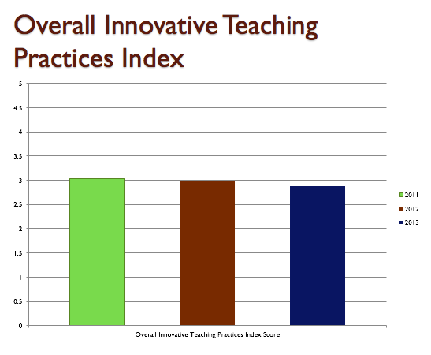
As measured by the Microsoft Partners in Learning School Research report, there was indeed a drop in innovative practices by teachers over the three years from 2011-2013 (see Figure 1, below), despite a clear continued use of ICT devices by both teachers and staff (see Appendix A). Clear drops were also identified across each sub-domain of the report, such as Personalised Learning, Collaboration, Knowledge Construction and Global Awareness.
Figure 1: Innovative Teaching Practices as measured by Microsoft Educator Network School Research report
What was less expected was that NAPLAN results also fell (Figure 2, next page) in line with drops in Innovative Practices, after rising during the previous period of time in which eLearning and digital pedagogies were the key focus (2008-2011).
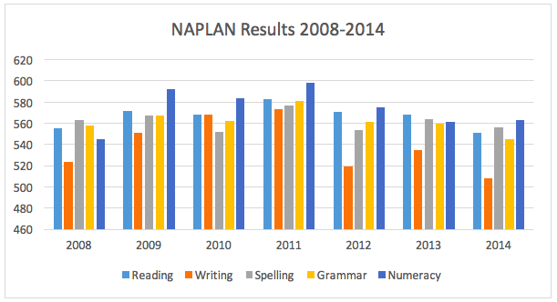
Figure 2: Year 9 NAPLAN results from 2008-2014

None of this is to suggest that the processes implemented by the new Principal were fundamentally ineffective. From my experience, High Classroom Expectations was very effective in assisting students in moving from Retreatism to a point where they were coming to class prepared to follow directions and complete work (Ritual Compliance), and the other processes ensured students cared about success, and were aware of how to achieve it. It was the focus on these processes to the detriment of the earlier work in developing authentically engaging work (using eLearning and digital pedagogies) that has resulted not just in moving students up from Retreatism to Ritual and Strategic Compliance, but also in dis-engaging students who were previously operating at the level of Authentic Engagement, and moving them down towards Ritual and Strategic Compliance.

Conclusion
Students come to our classes at different levels of engagement. As teachers, we aim to engage them all authentically so that not only can they find success in our classes, but that they are able to retain and apply the knowledge they have learnt in other contexts, and beyond the classroom. In order to achieve this, schools need to have access to a range of school-wide processes and Instructional Techniques, based on different Learning Theories, in order to meet the needs of all of the students in front of us. By improving student engagement through the use of appropriate processes, we are able to optimise authentic learning in our classrooms.

Bibliography
Andrews, J. (2014, January 15). Engagement: not motivation, nor conformity. Retrieved September 10, 2015, from Centre for Research Innovation and Future Development: http://thecentreonline.com.au/2014/01/15/engagement-motivation-conformity/

Ausubel, D. P. (1961). In defense of verbal learning. Educational Theory , 11 (1), 15-25.

Engineers Without Borders. (2014). EWB Challenge. Retrieved September 20, 2015, from EWB Challenge: http://ewbchallenge.org

Fullan, M. (2014). The Principal. San Francisco: Jossey-Bass.

Kreber, C. (2013). Empowering the scholarship of teaching: an Arendtian and critical perspective. Studies in Higher Education , 38 (6), 857-869.

Lombardi, M. M. (2007). Authenit Learning for the 21st Century: An Overview. In D. G. Oblinger (Ed.), EDUCASE Learning Initiative.

Machiavelli, N. (1513). The Prince [Kobo ed.]. Florence.

Microsoft Educator Network. (2015). 21st Century Learning Design. Retrieved September 20, 2015, from Microsfot Educator Network: https://www.educatornetwork.com/pd/21CLD/Overview

Microsoft Educator Network. (2015). Partners in Learning School Research Overview. Retrieved September 21, 2015, from Microsoft Educator Network: https://www.educatornetwork.com/Sites/SchoolResearch/ForSchools/Index

Peters, M. A. (2014). The Shapes of Theory in Education. Educational Philosophy and Theory , 46 (12), 1315-1319.

Peterson, R. A. (2005). In Search of Authenticity. Journal of Management Studies , 42 (5), 1083-1098.

Rule, A. C. (2006). Editorial: The Componenets of Authentic Learning. Journal of Authentic Learning , 3 (1), 1-10.

Saito, H. (2010). Actor-network theory of cosmopolitan education. Curriculum Studies , 42 (3), 333-351.

Schlechty, P. (2011). Schlechty Centre on Engagement. Retrieved September 20, 2015, from Schlechty Centre: http://www.schlechtycenter.org/system/tool_attachment/4046/original/sc_pdf_engagement.pdf?1272415798

Schuh, K. L., & Barab, S. A. (2008). Philosophical Perspectives. In J. M. Spector, M. D. Merrill, J. v. Merrienboer, & M. P. Driscoll (Eds.), Handbook of Research on Educational Communications and Technology 3rd Edition (pp. 67-82). New York, NY: Lawrence Erlbaum Associates.

Sumara, D. J., & Davis, B. (1997). Enactivist Theory and Community Learning: toward a complexified understanding of actino research. Education Actino Research , 5 (3), 403-422.

Appendix A
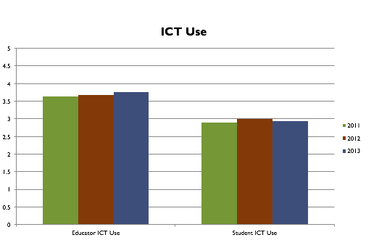
Results of Partners in Learning School Research Report 2011-2013
Figure A1 Teacher and Student ICT Use, 2011-2013
Figure A2 Effective use of Student Centred Pedagogies, 2011-2013
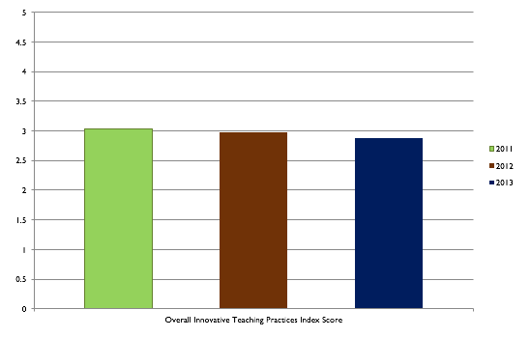
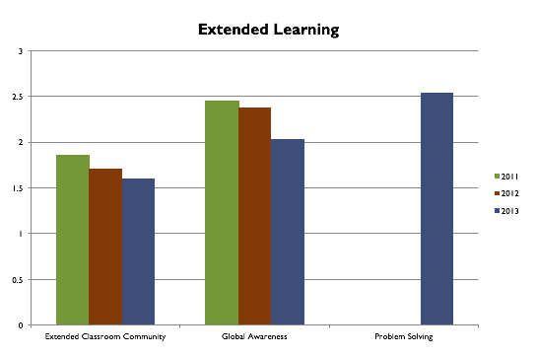
Figure A3 Extended Learning in the classroom, 2011-2013

Figure A4 Overall Innovative Teaching Practices Index 2011-2013

